**Wk8 Murach Coding Assignments (Individual) George Gachoki, 6/2/2020**

**Extra 12-1 Create and use an inventor Item class**

**GitHub URL:**

**Compiling build and run**

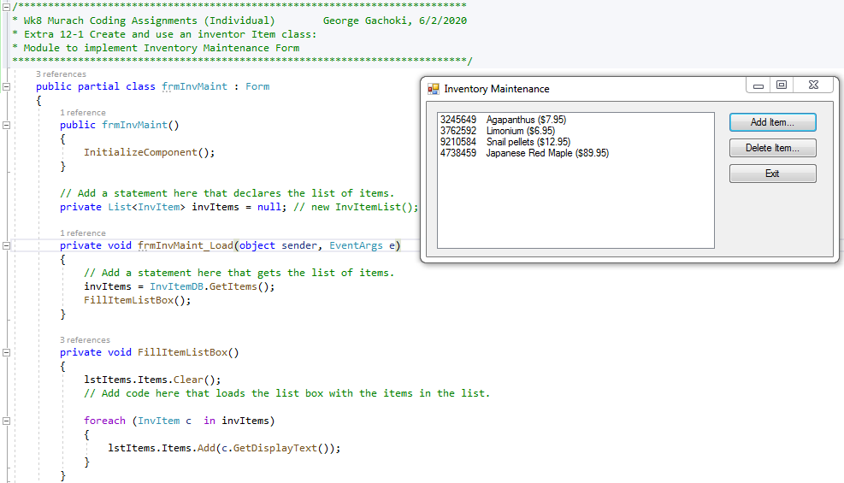

**Adding a New Inventory Item**

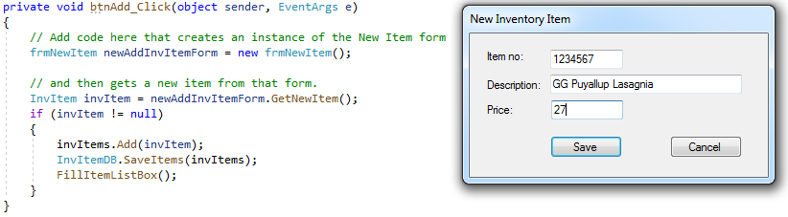

**Deleting an Inventory Item**

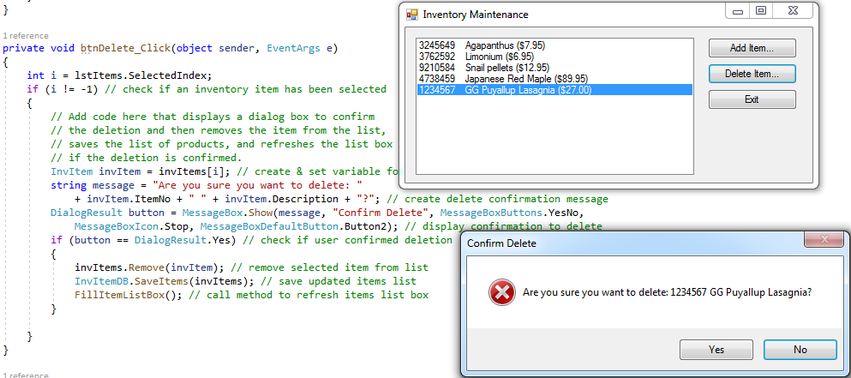

**Testing for blank entry**

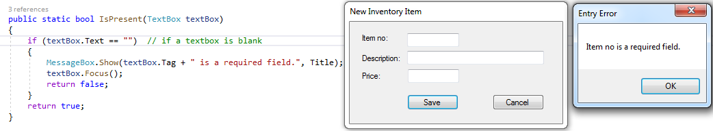

**Testing for required number entry**

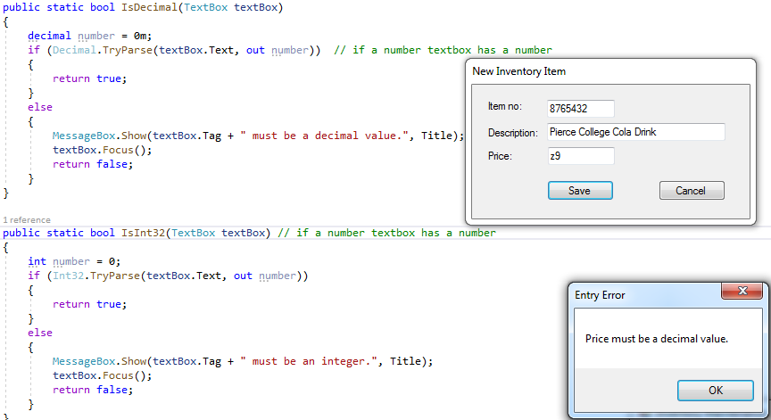

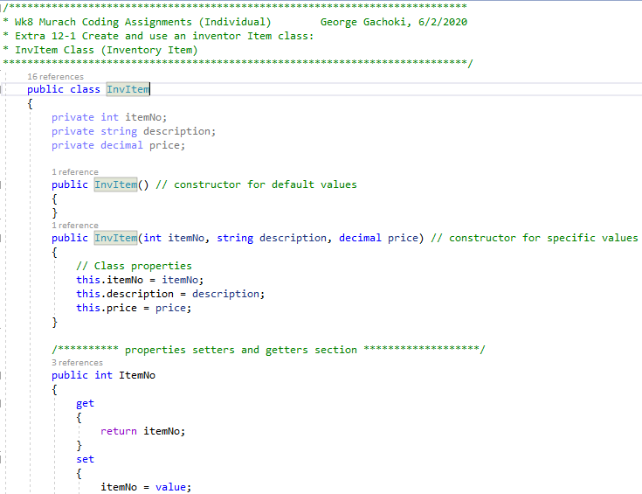

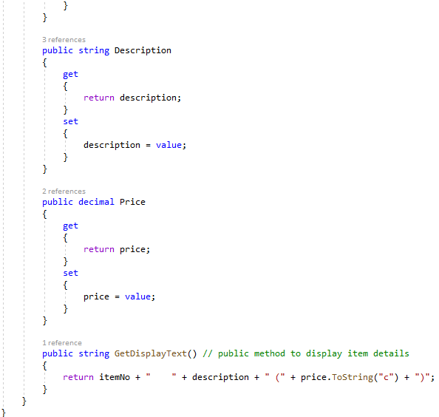

**Intentional exit**

